1. 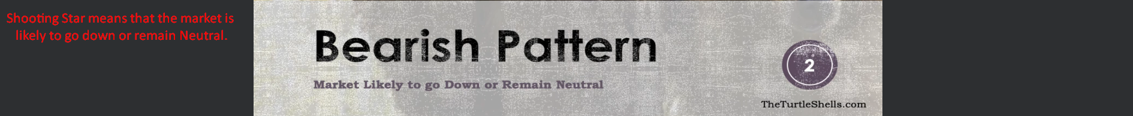  
   It will likely go down or become sideways.
2. Let’s see how Shooting Star is constructed.
3. 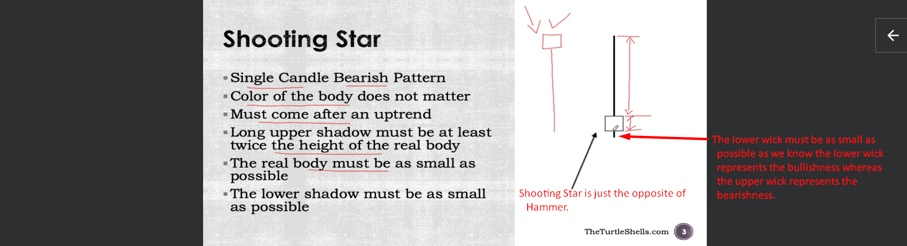  
   **NOTE**: If the Colour of the body is Black then better as Shooting Star represents the Bearishness.   
   **NOTE**: It is fine if Hammer comes after a small downtrend but Shooting Star must come after long uptrend. This is the main distinguishing point b/w Hammer and Shooting Star.
4. 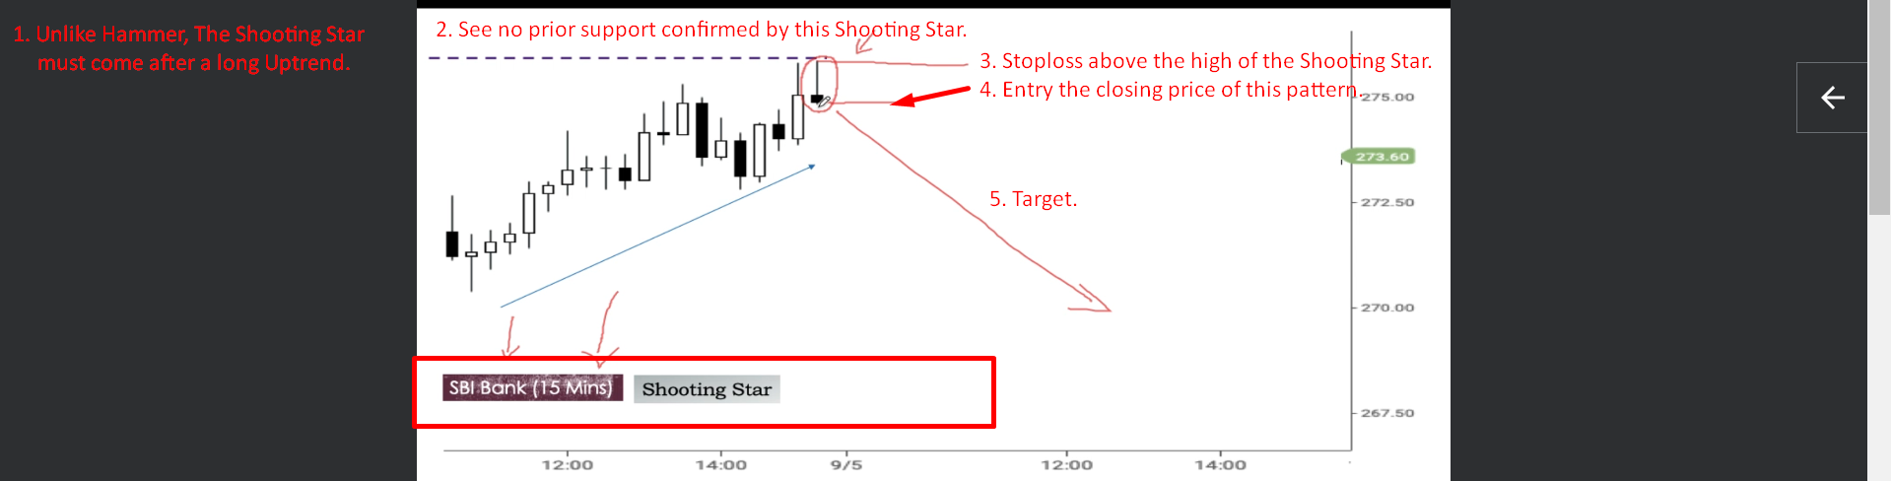
   1. Market is going up when Shooting Star appeared.
5. 